| **COS106- Programming with Java**  British University College NandarAung (1334) | |
| --- | --- |
| Table of Contents  About Program [3](https://docs.google.com/document/d/1NAF1ybAnh3FcWfupyjhyN0l-9aZT4UcAjarYYeMwZDc/edit#heading=h.2et92p0)  Entity Relationship Diagram  [4](https://docs.google.com/document/d/1NAF1ybAnh3FcWfupyjhyN0l-9aZT4UcAjarYYeMwZDc/edit#heading=h.tyjcwt)  [Designing Databases and Data](https://docs.google.com/document/d/1NAF1ybAnh3FcWfupyjhyN0l-9aZT4UcAjarYYeMwZDc/edit#heading=h.3dy6vkm) 5  Coding and Validation7  MainMenu Form11  Client Information12  Product Form20  Create Table Form21  Data Edition Form24  Edit Table Definition Form ………………………………………………………………29 |  |
|  |  |

# **ABOUT PROGRAM**

The TV Repair System is a software application designed to assist TV repair shops in managing customer information, details of TV repairs, and work on TVs. Developed using the Java programming language for user-friendly and efficient functionality, the application consists of five forms: table creation, customer management, item management, column manipulation, and admin login. Admin users, in the client and item management forms, possess the authority to perform actions such as adding, updating, removing, and searching data, along with additional privileges. Administrators can search, modify, and remove data from the client and item forms. The create table form enables admins to modify table columns and create new tables in the database. The column form allows administrators to add, edit, and remove data from table columns. Admins can manipulate data in tables, including adding, updating, and deleting, using the data manipulation form. The application features screenshots of code snippets, and each form is linked to a database. The database has separate sections for managing logins, clients, and items, with diagrams showing how they are connected. There are rules to check that the data entered for logins, clients, and items is accurate. Moreover, the application has features to automatically create code, display selected information on the screen, and assist in adding new items to forms.

# **Entity-Relationship Diagram**

# 

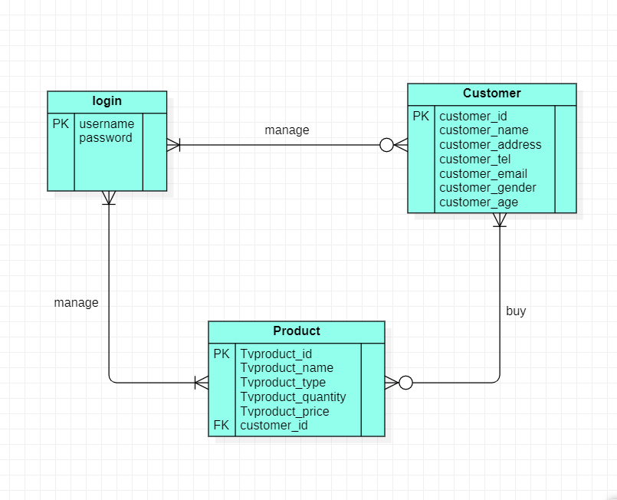

Multiple users can access the program, as indicated in the diagram. The company may have zero or numerous customers. At a minimum, the business will market one or more products, and customers have the option to purchase one, multiple, or no products.

### **Designing Databases and Data**

### 

##### **Login Table (userlogin)**

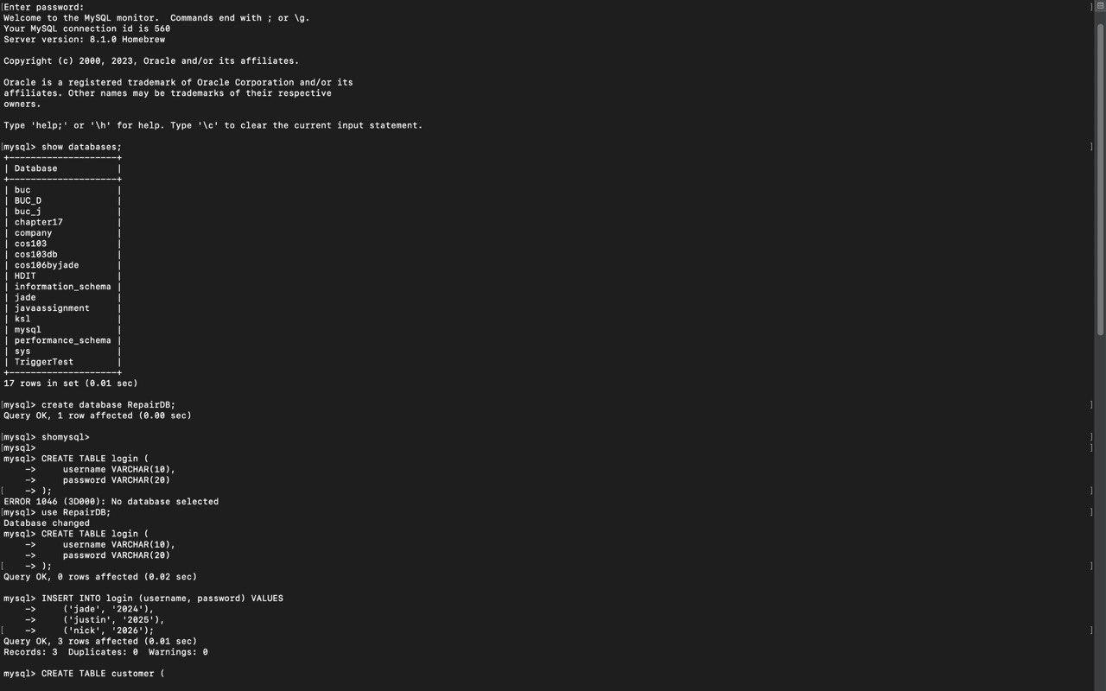

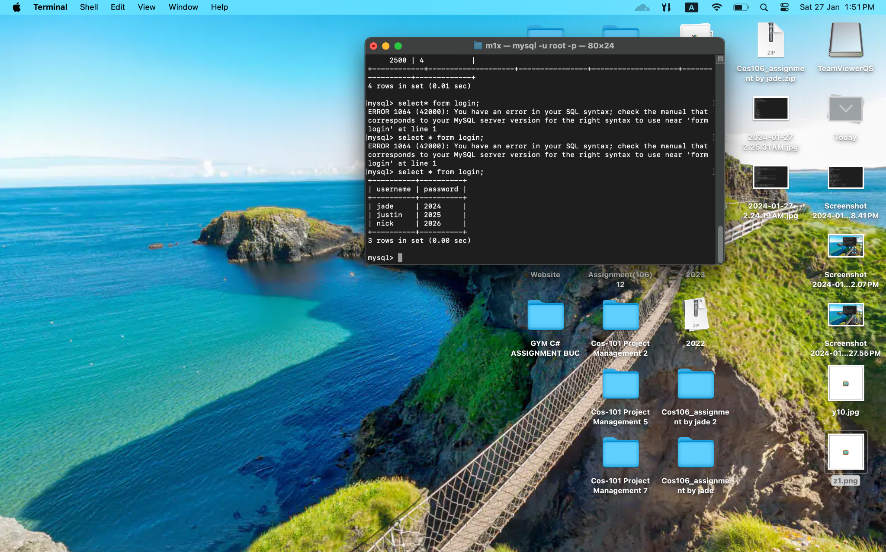

##### **Customer Table (customer)**

# 

##### **tv Product Table**

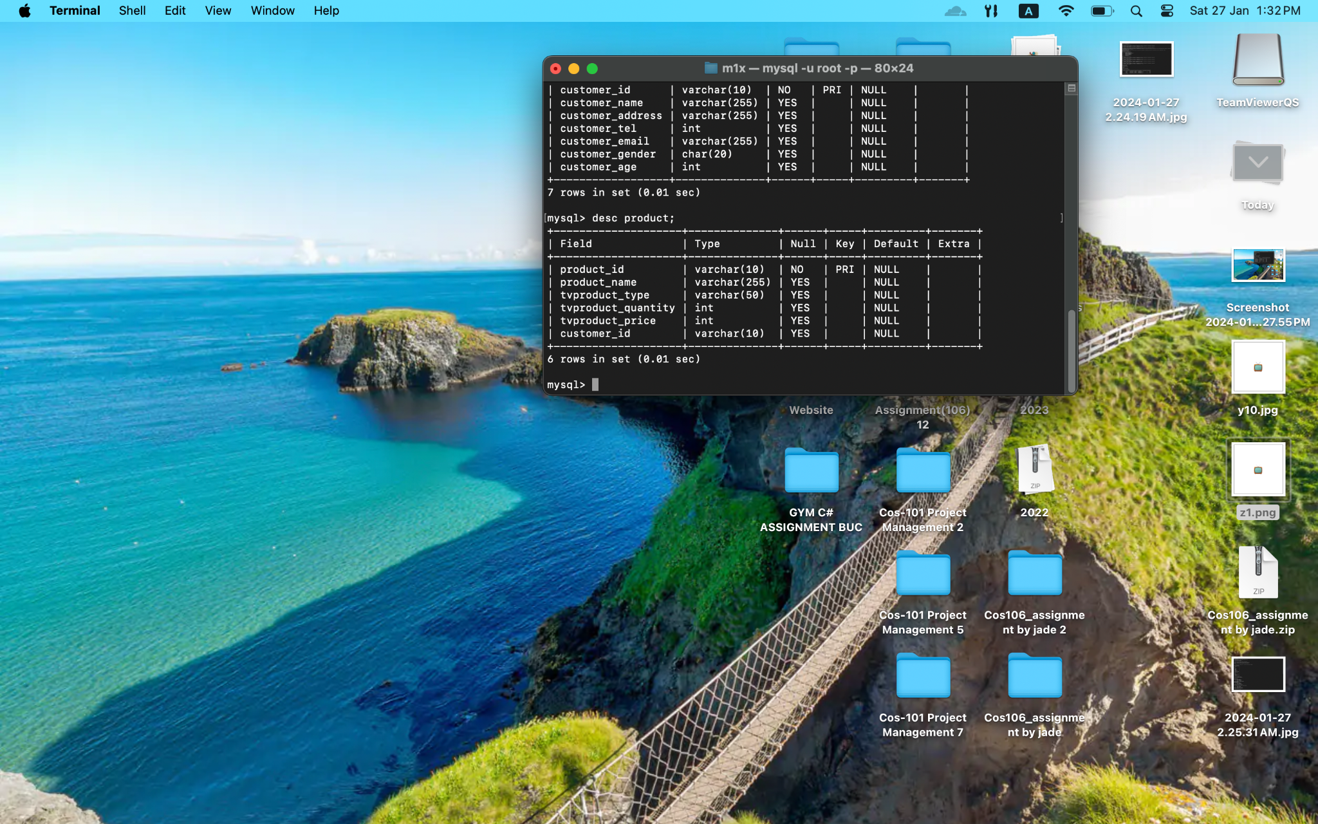

# 

### **Coding and Validation**

The initial program form ensures secure user interaction. Before taking any action, users must log in with their credentials. Incorrect inputs prompt an appropriate program response.

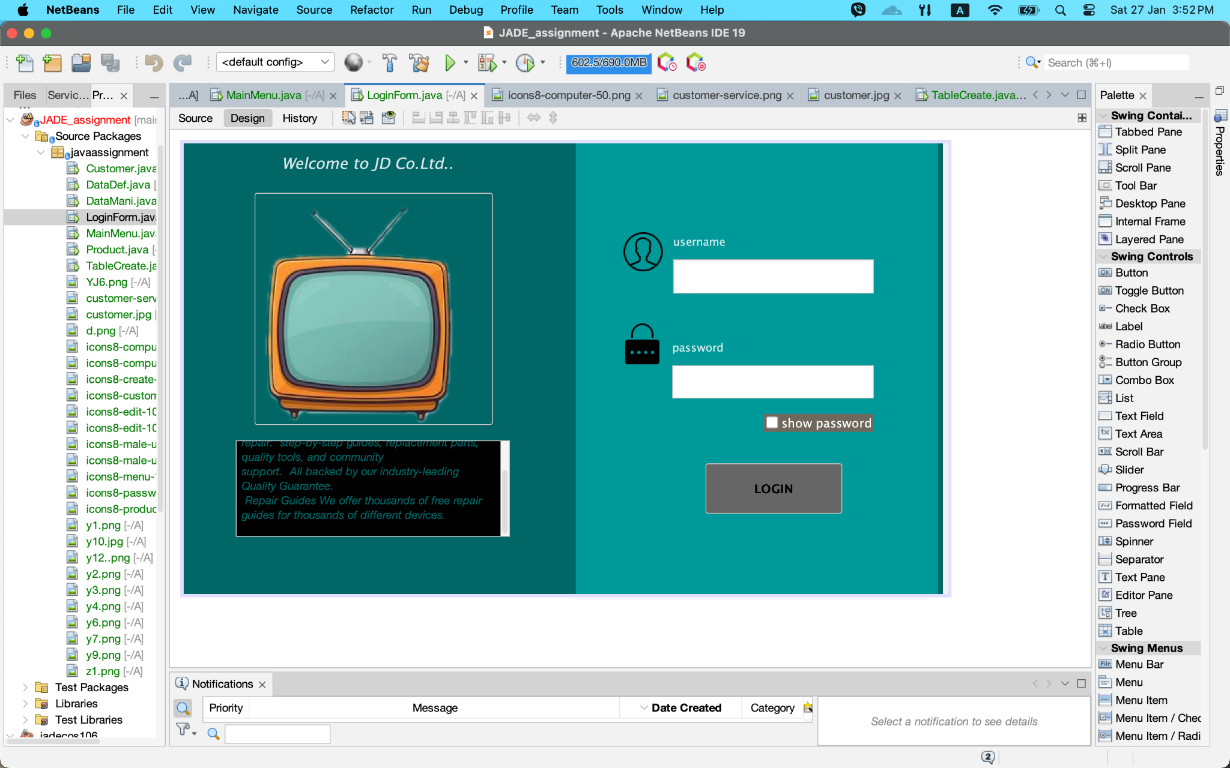

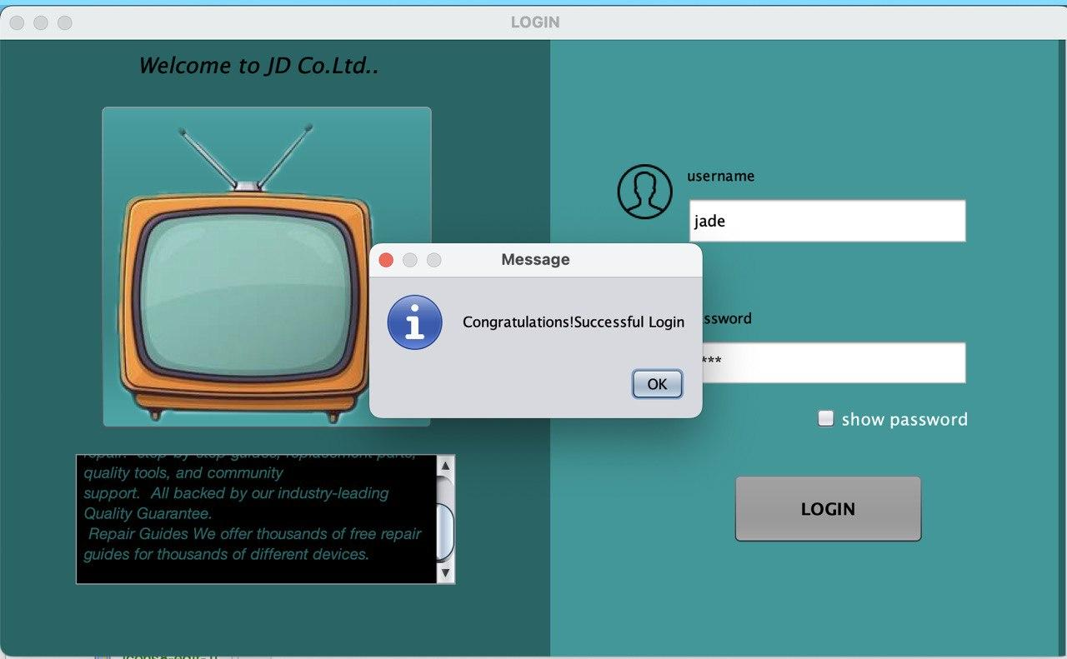

If the user enters an incorrect username and password, the login attempt will be unsuccessful.

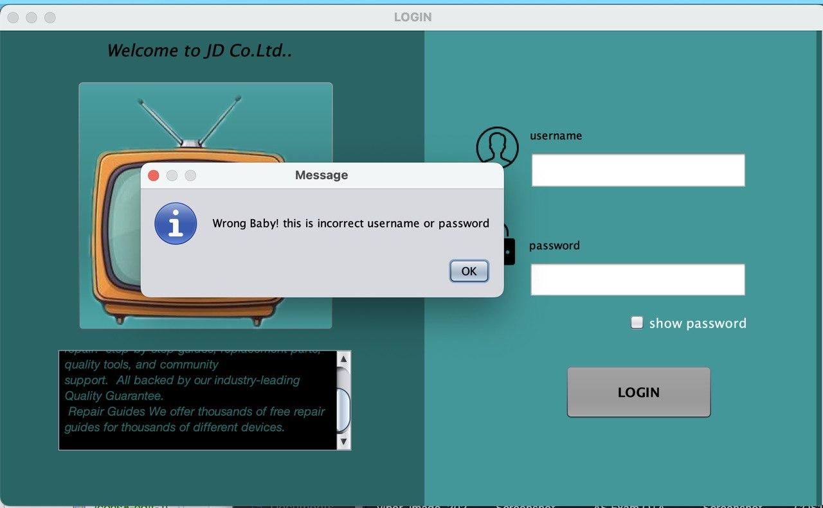

If the user provides an incorrect username or password, the program will display an error message.

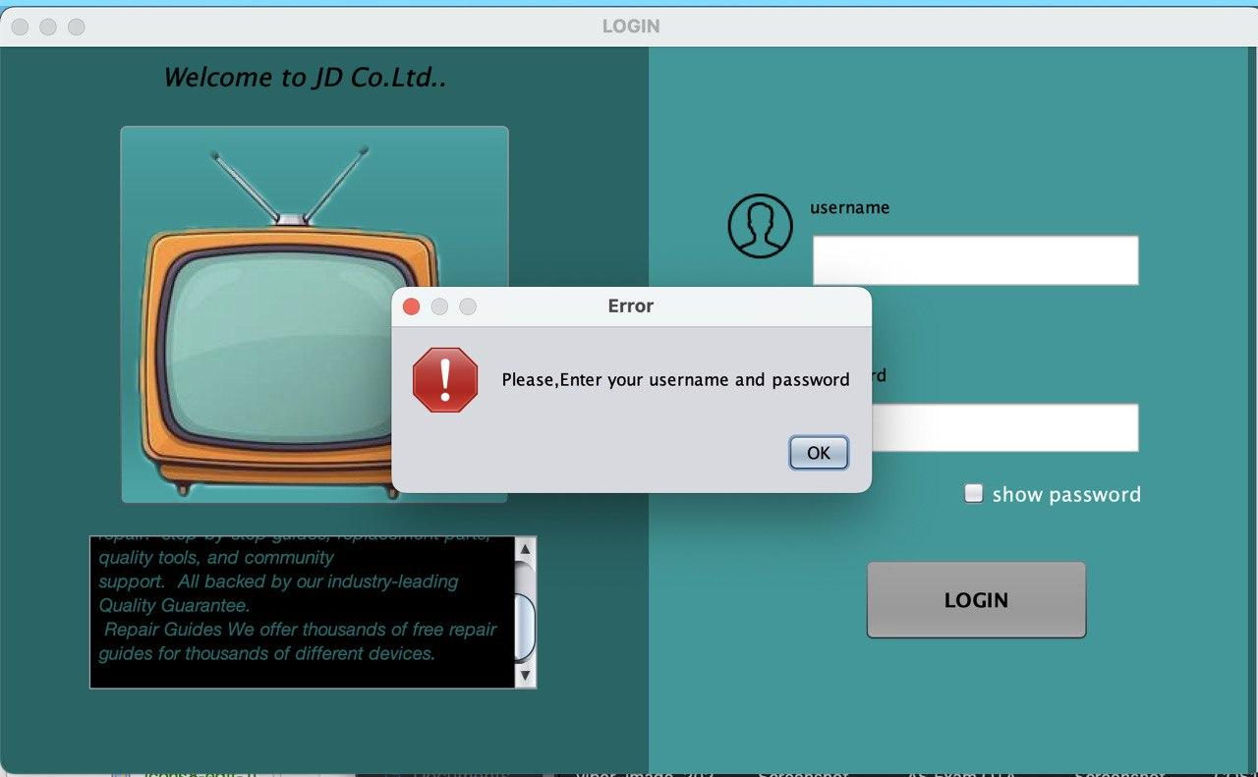

* This represents the initial version of my program. When a user intends to perform an action, logging in is a prerequisite. In such instances, the user needs to input an accurate username and password. If the input is invalid, the program will display the following message.

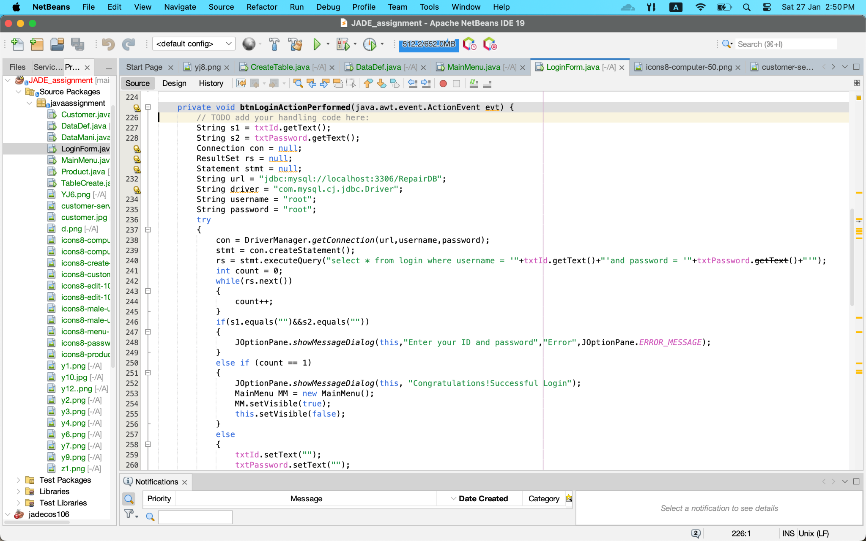

## 

## 

## **Main Menu Form**

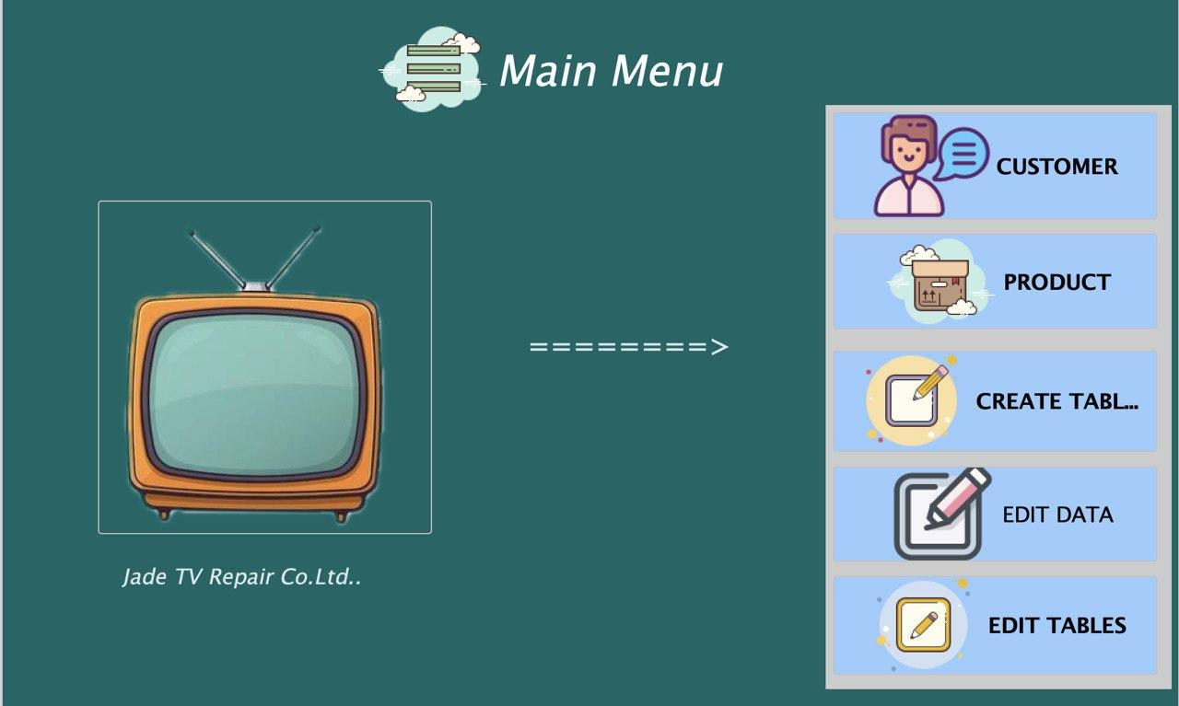

In the Main Menu Form, each button can be clicked by the user to navigate to specific forms. For instance, clicking the 'customer' button will display the customer form, enabling the ability to examine and modify customer table data. In a similar vein, clicking the "product" button brings up the product form, where the user can check and edit data.

Click 'create tables' to open the table definition form and start creating tables. Use the 'edit data' button to access the Data Manipulation form in order to edit data. Click 'edit tables' to add, update, or remove columns from the tables in order to change the table definitions.

## **Client Information**

## 

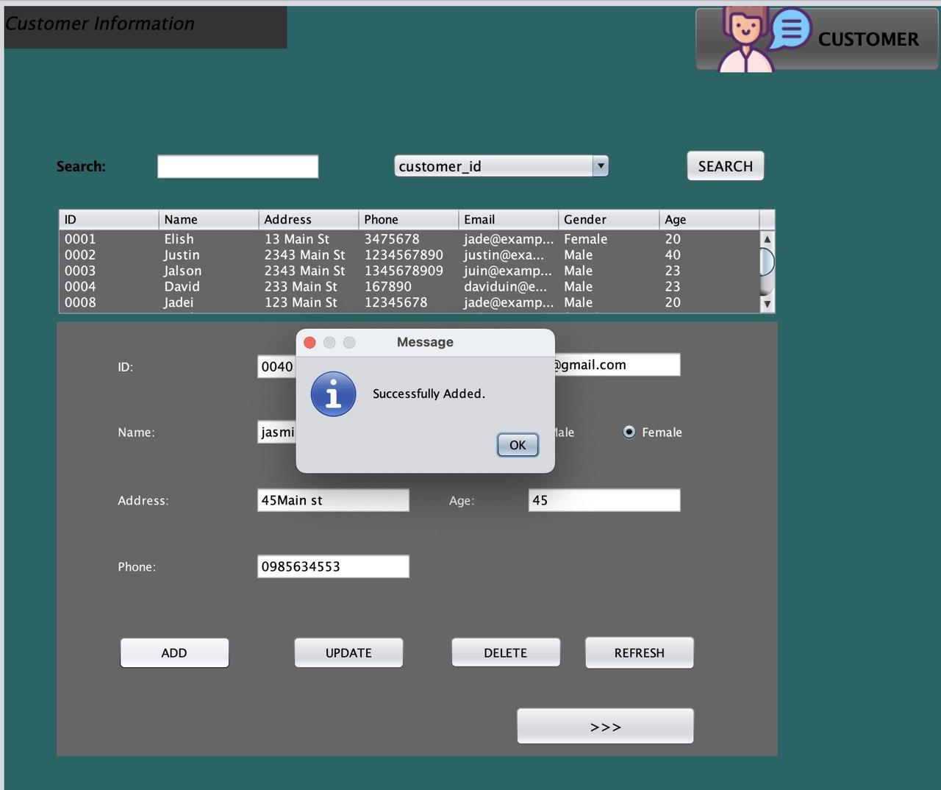

Selecting the 'customer' button in the main menu will display the customer form. To add a new entry to the database, input data into the text fields.

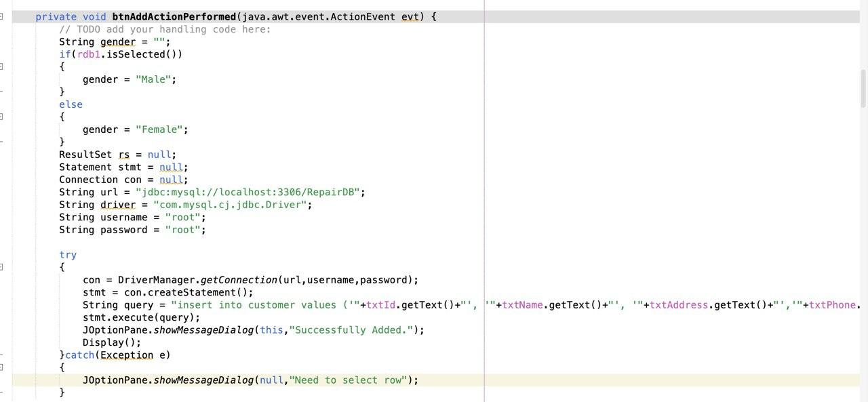

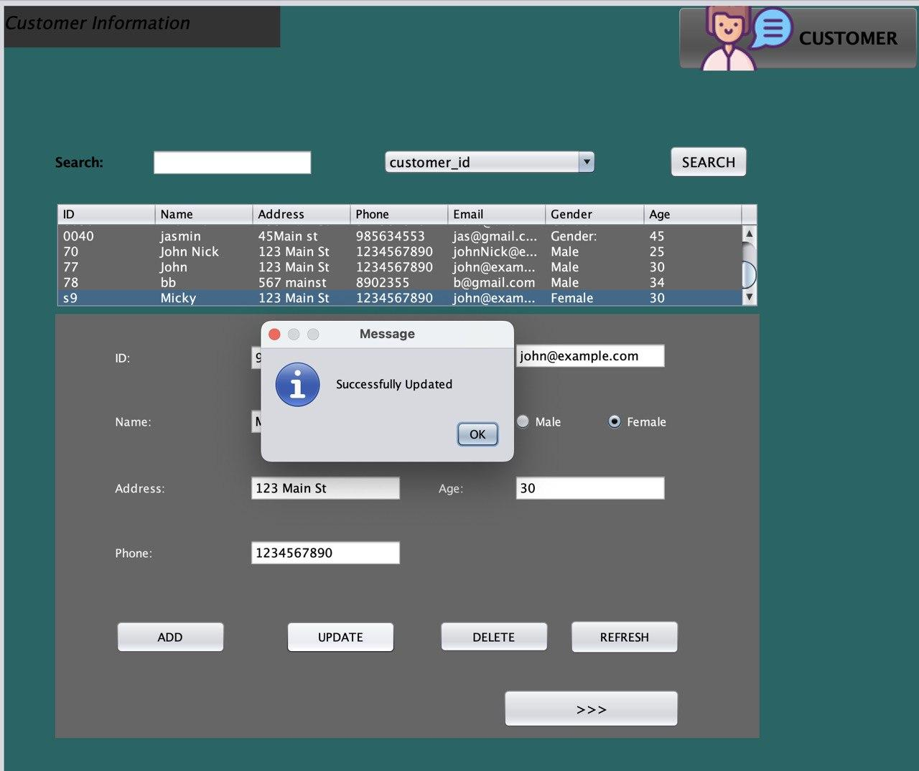

Users can edit existing entries by modifying data directly in the text fields.

.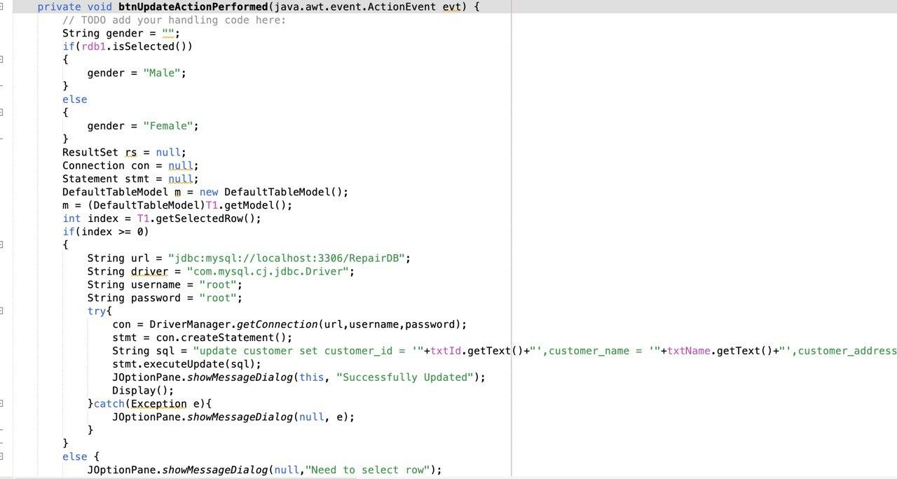

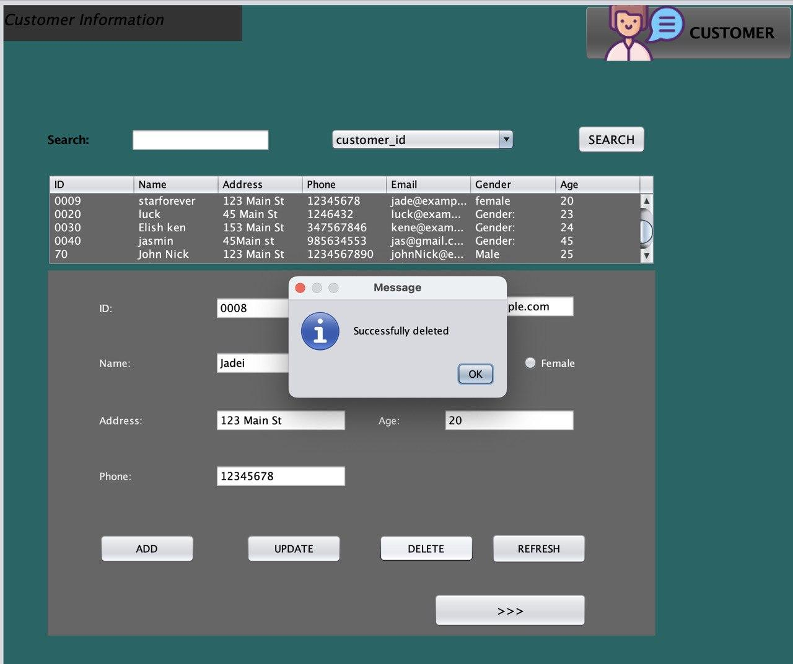

Users can remove rows by selecting them and using the delete button.

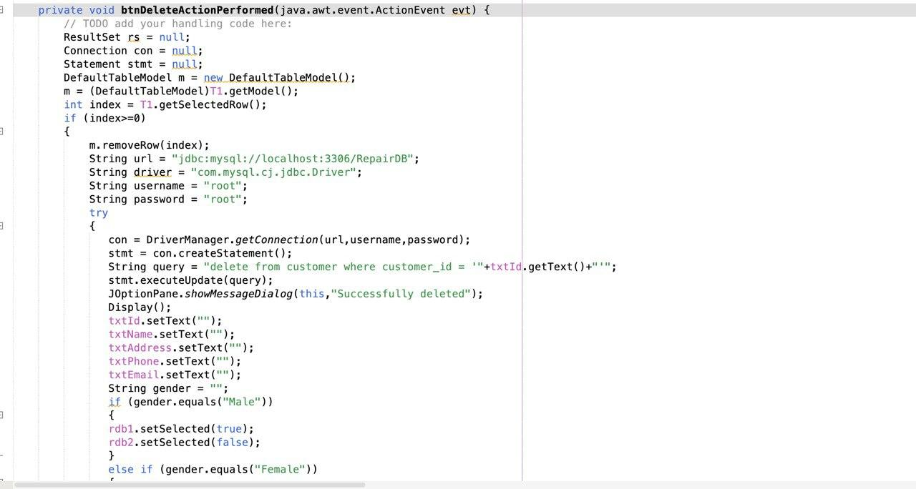

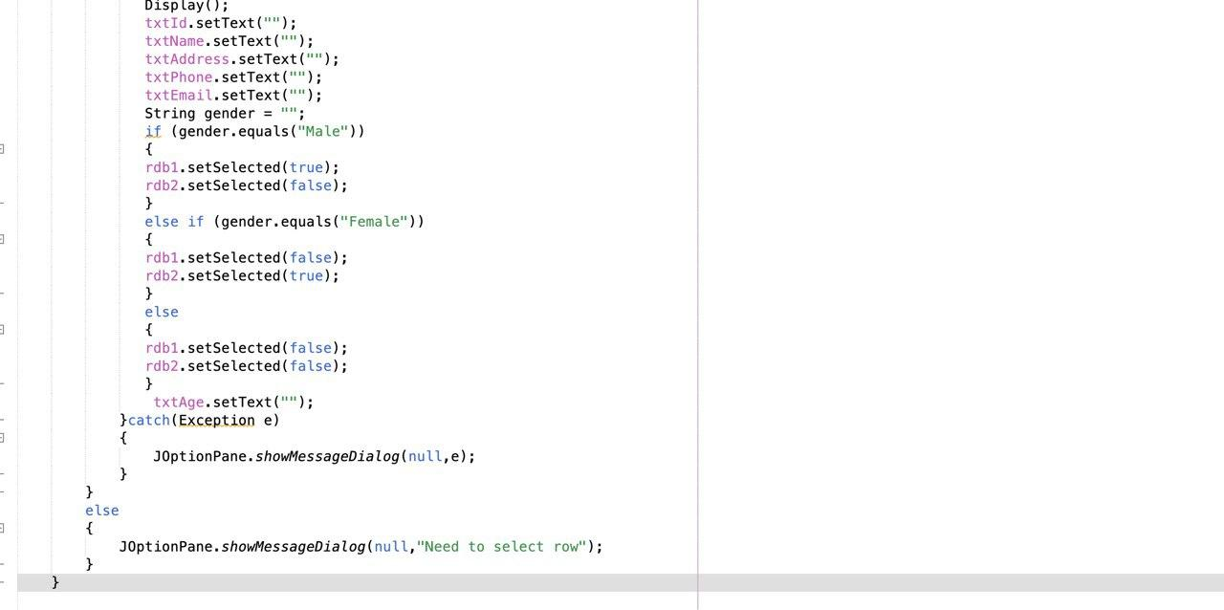

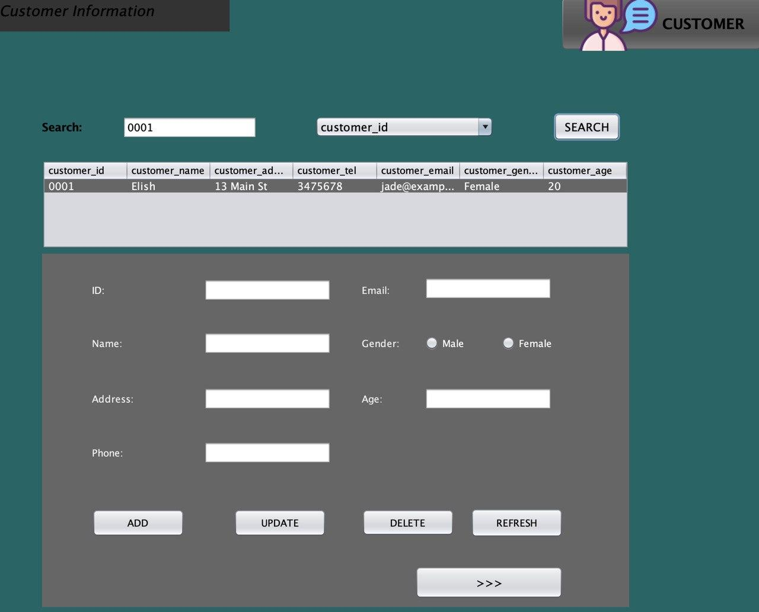

Users have the ability to search for customer details by selecting the category and entering the corresponding information into the designated text field.

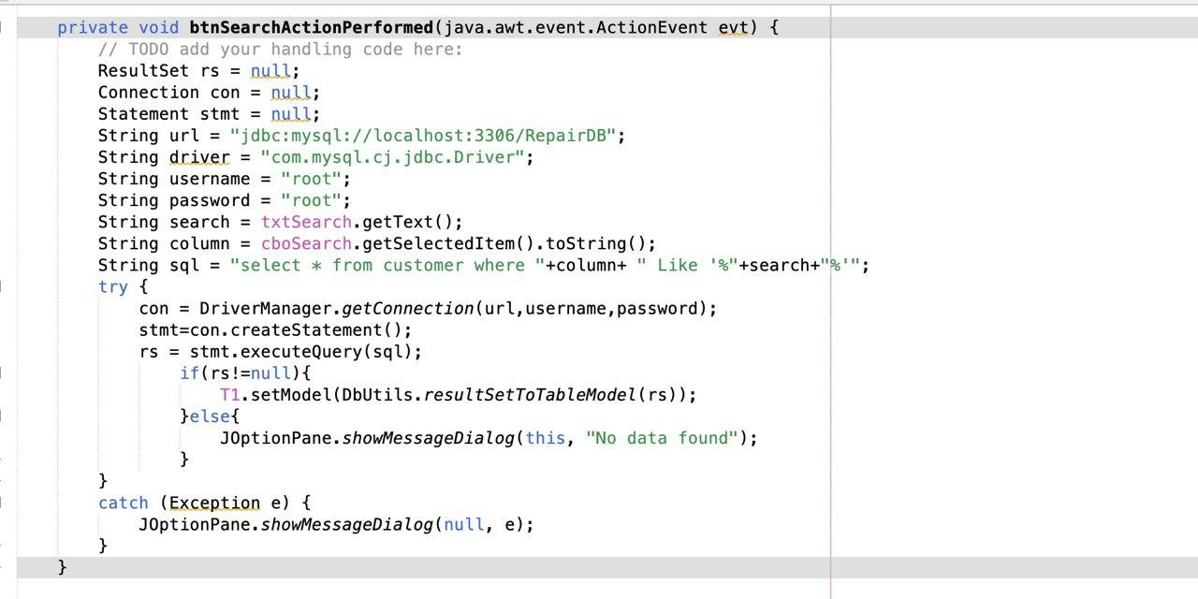

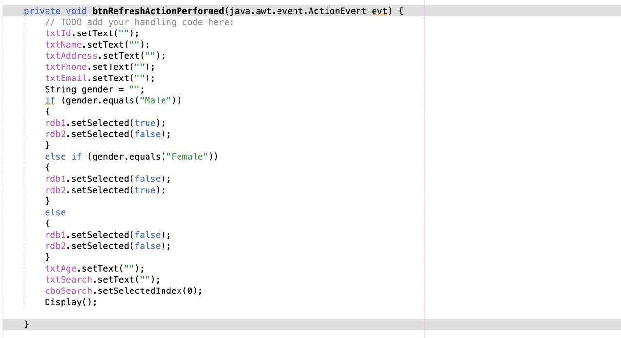

## **Product Form**

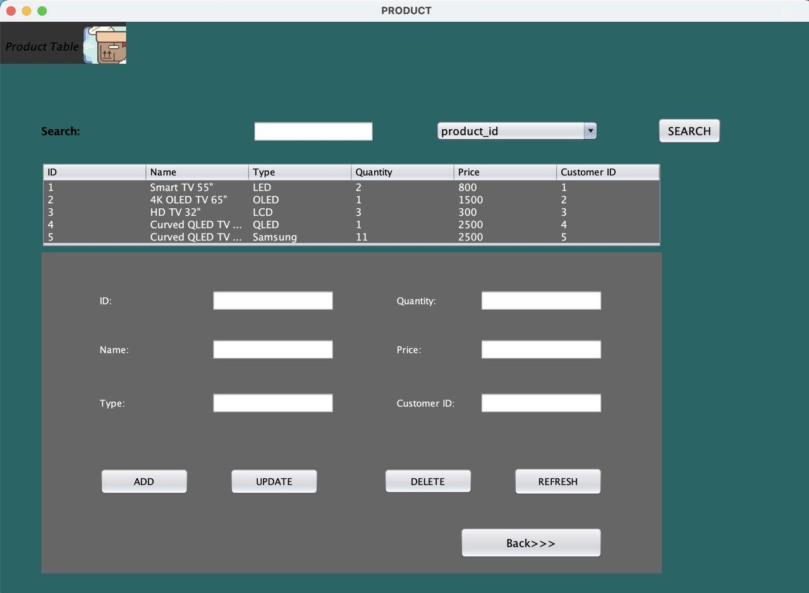

The user can handle details about products in a manner similar to how you handle client information. In order to do this, you must add new data, update current entries, delete rows, refresh text fields, and search for specific items in the combo box based on their types.

## **Create Tables Form**

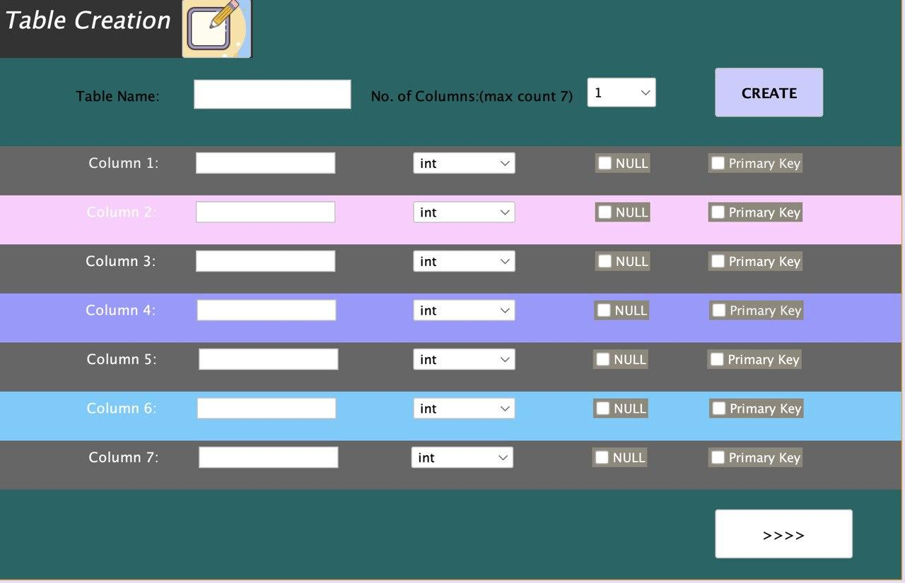

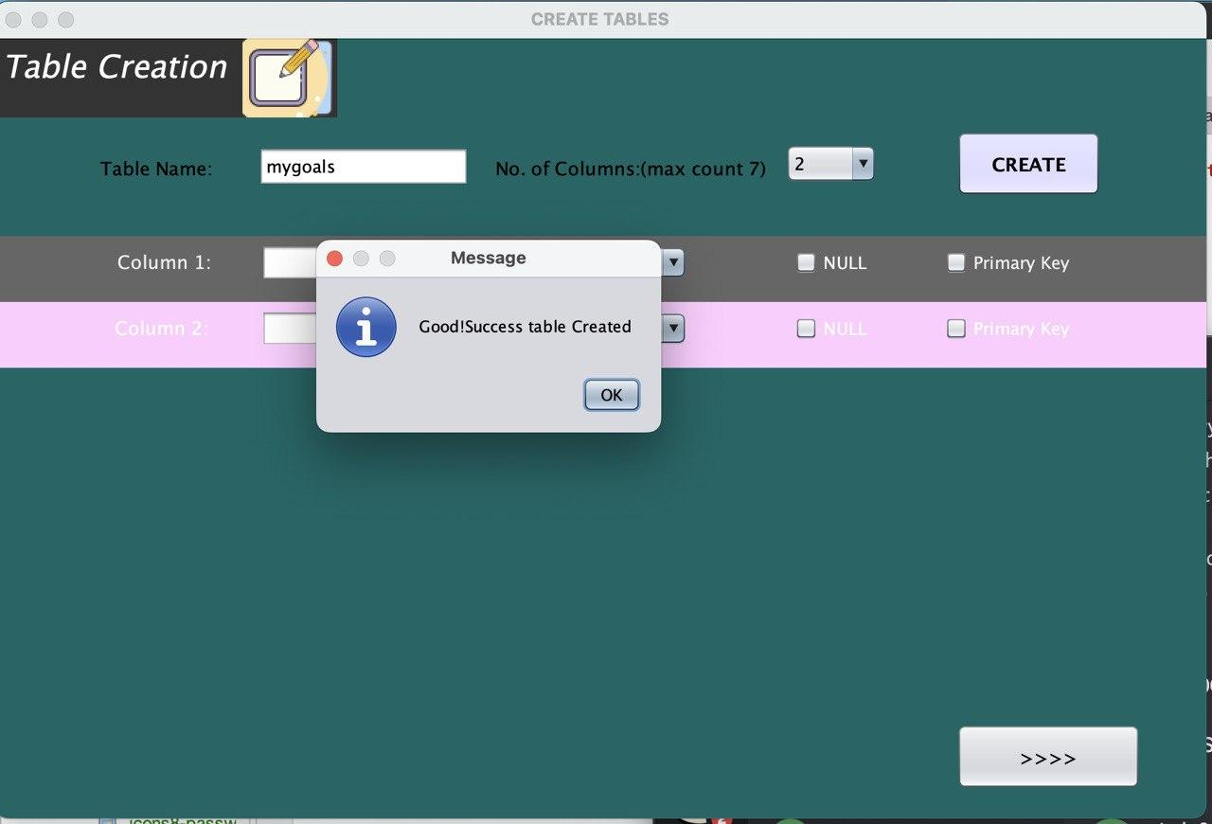

Clicking the 'create' button will add the newly defined table to the database.

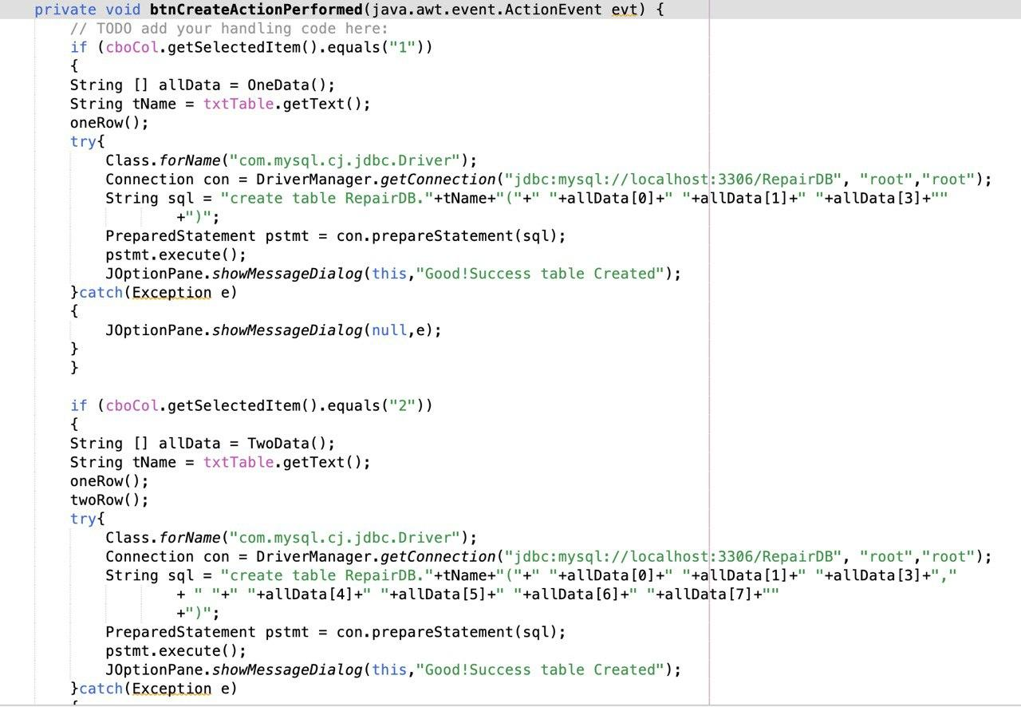

## **Data Edition Form**

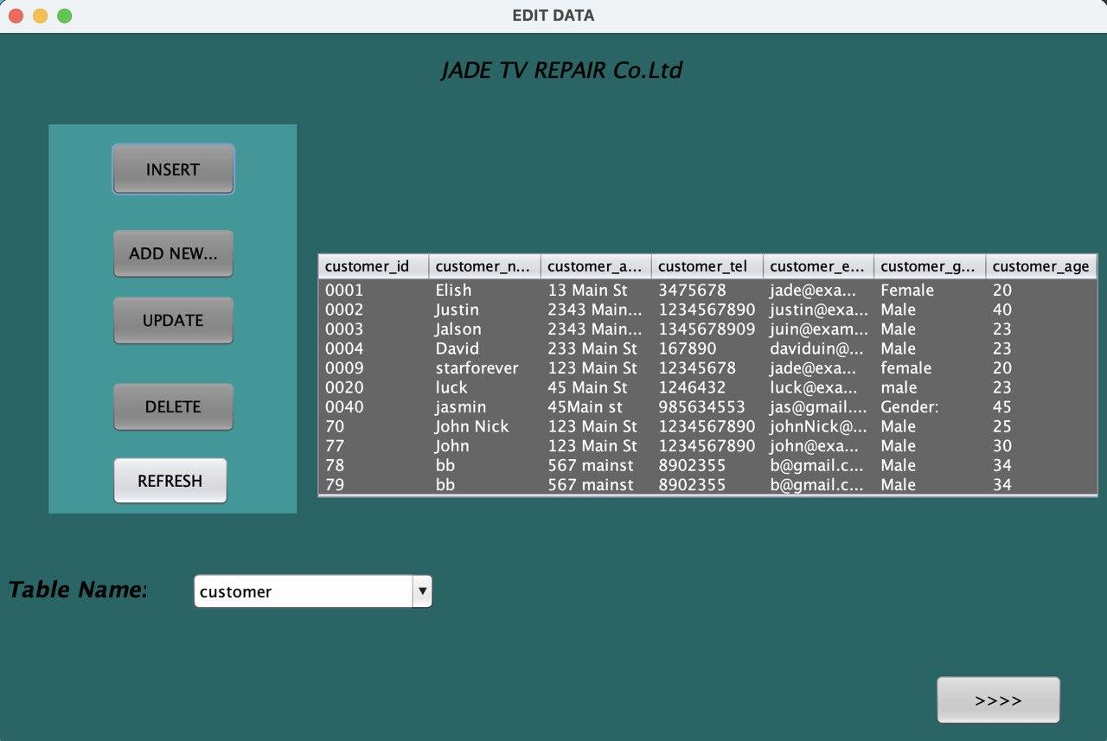

All database tables—aside from the "login" table—will be visible during Form Load in order to shield data from unauthorized alteration by database-accessible users.

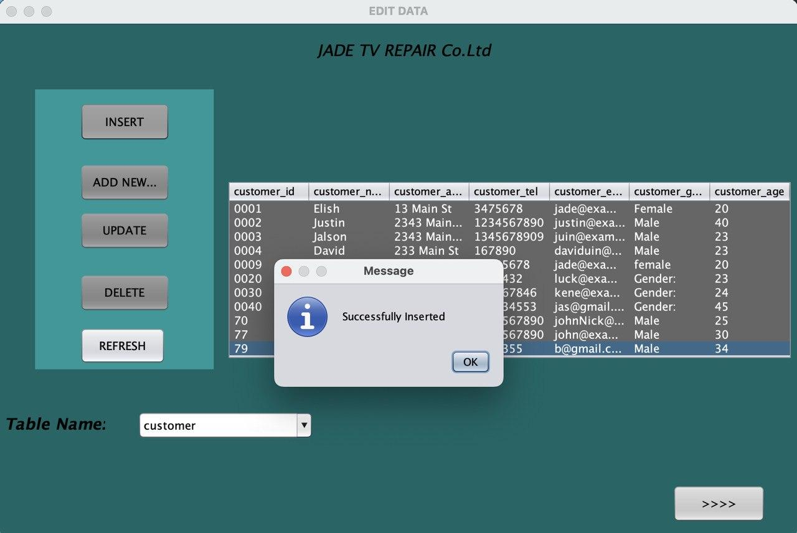

To input new data into the table, users start by clicking the 'add new row' button, which generates a new row for data entry. After inputting the data, users can confirm by clicking the 'insert' button, and a message confirming successful insertion will be displayed.

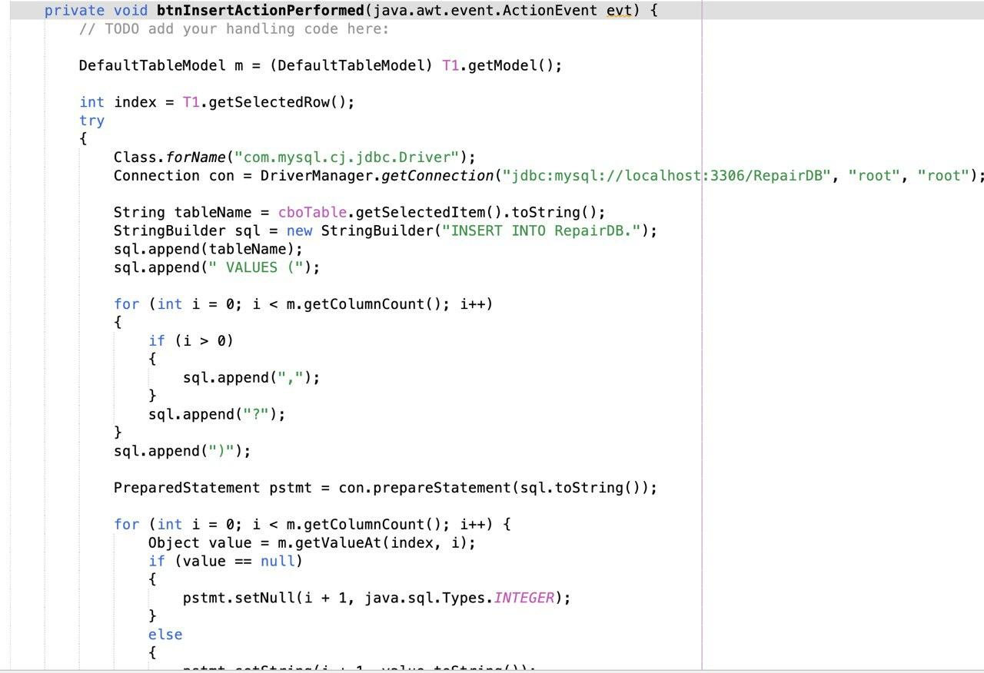

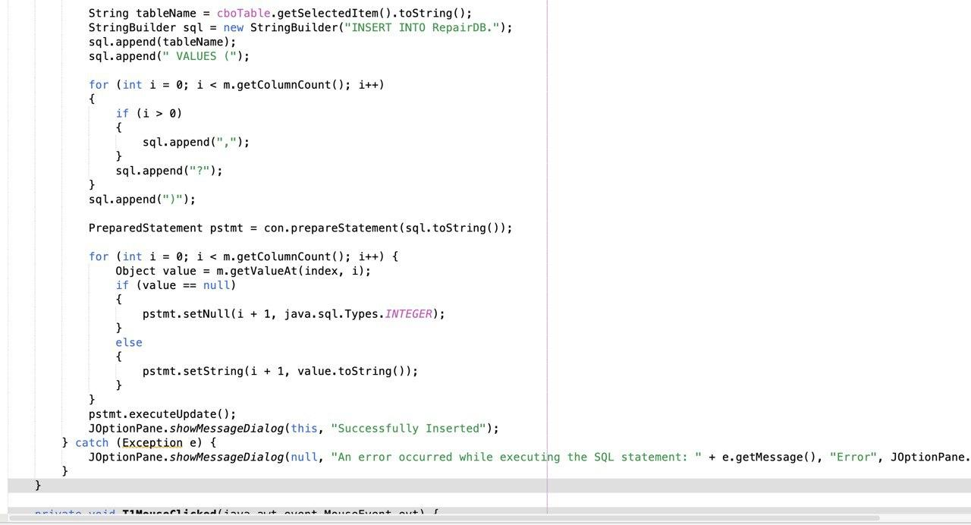

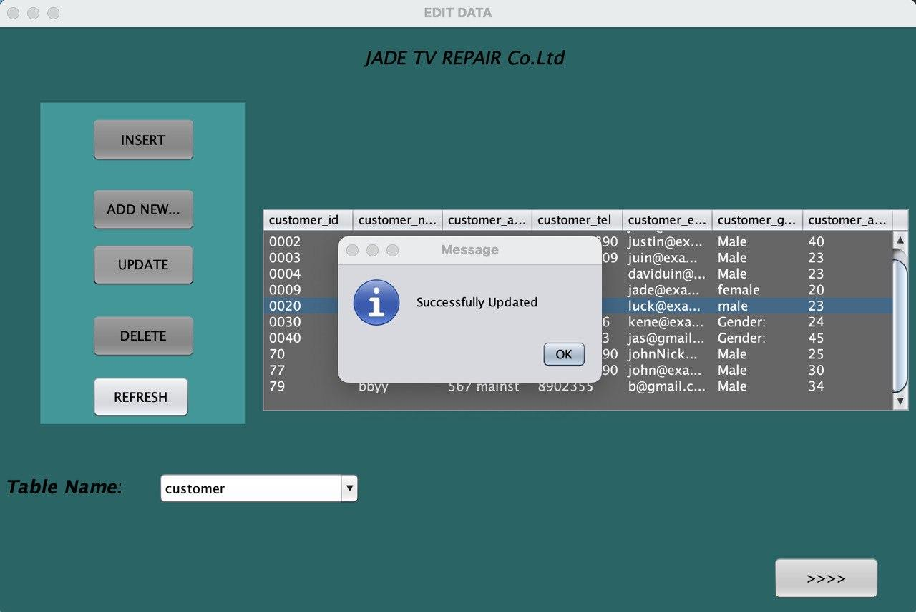

Users can update by editing existing rows and entering new data. Upon completion, a message confirming the successful update will be displayed in the database.

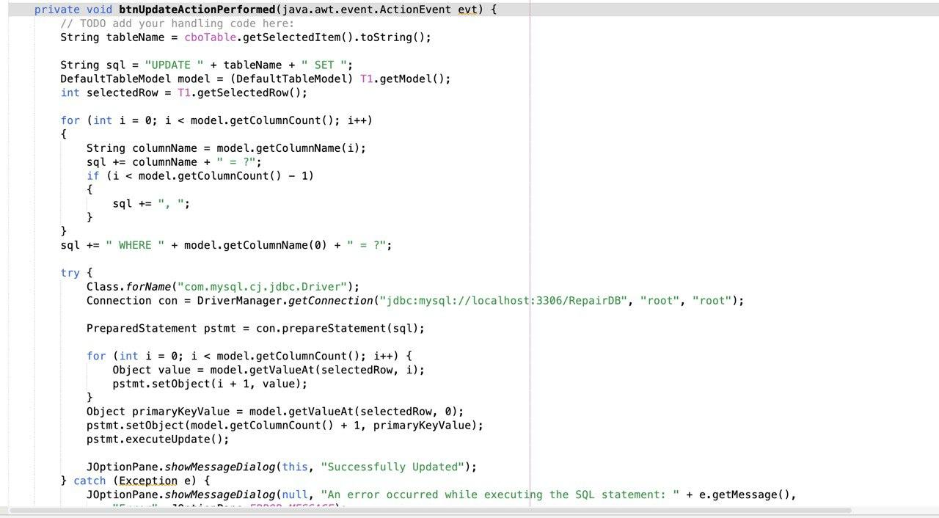

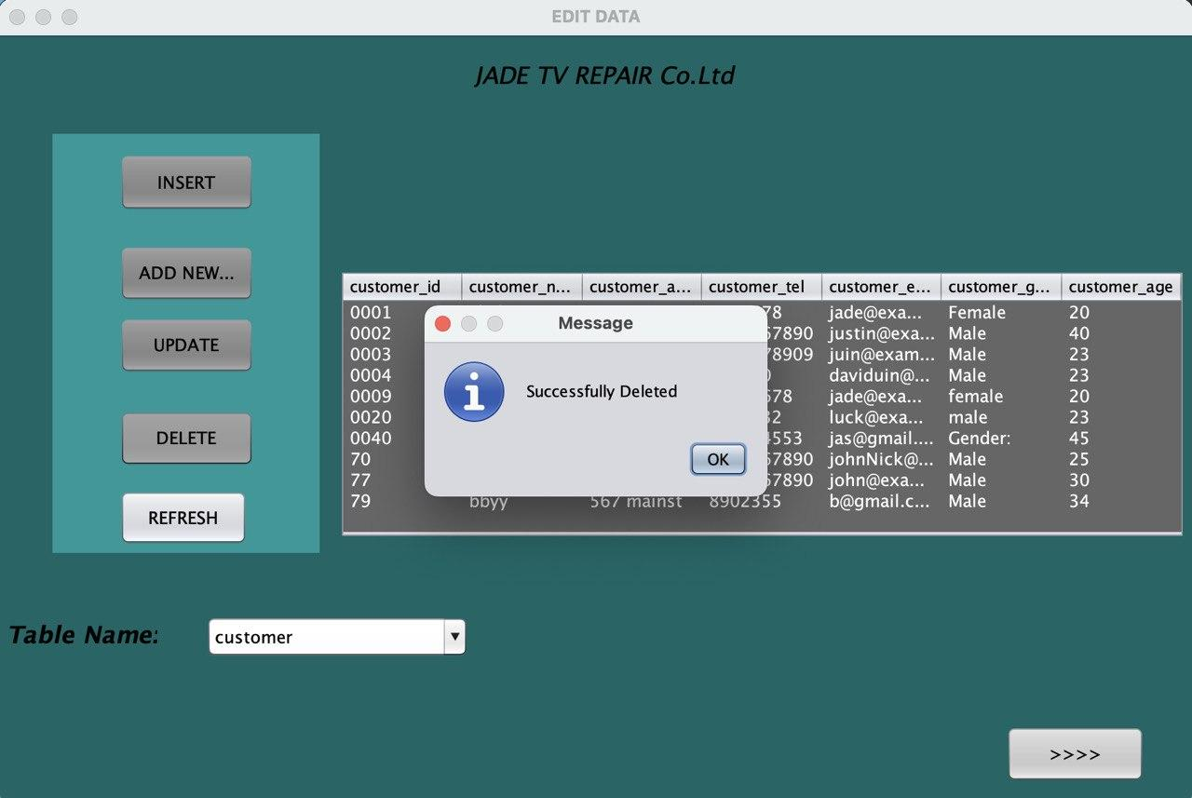

Users can delete rows from tables by selecting the row and clicking the 'delete' button. After deletion, a message confirming 'Deleted Successfully' will be displayed.

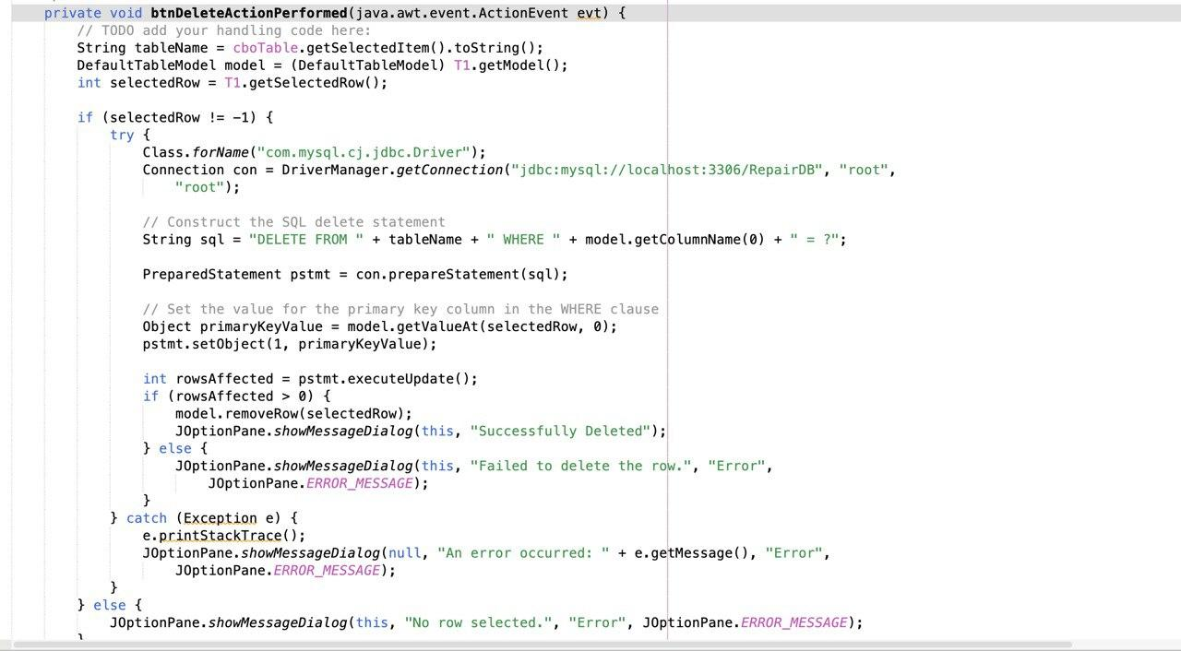

## **Edit Table Definition Form**

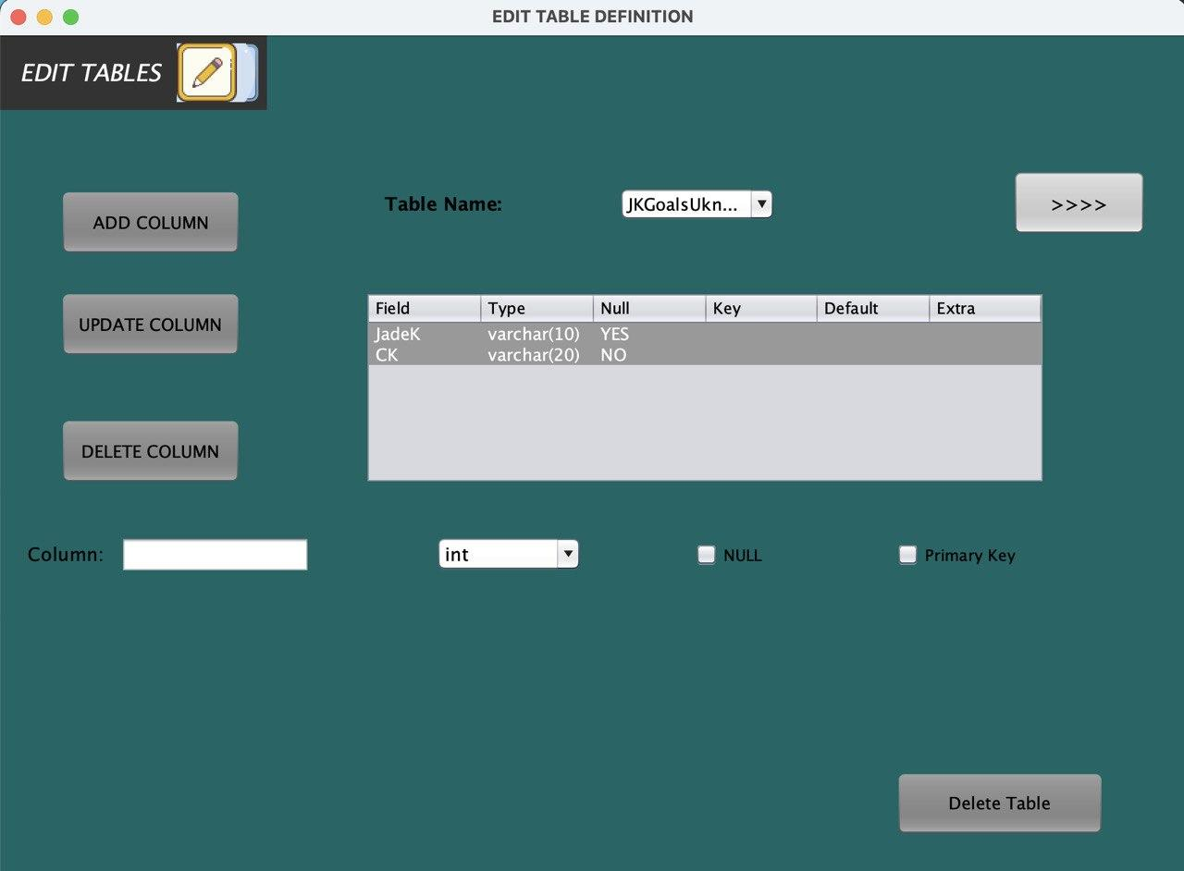

The customer and product tables will not be displayed when the form loads; instead, tables from the database will be displayed.

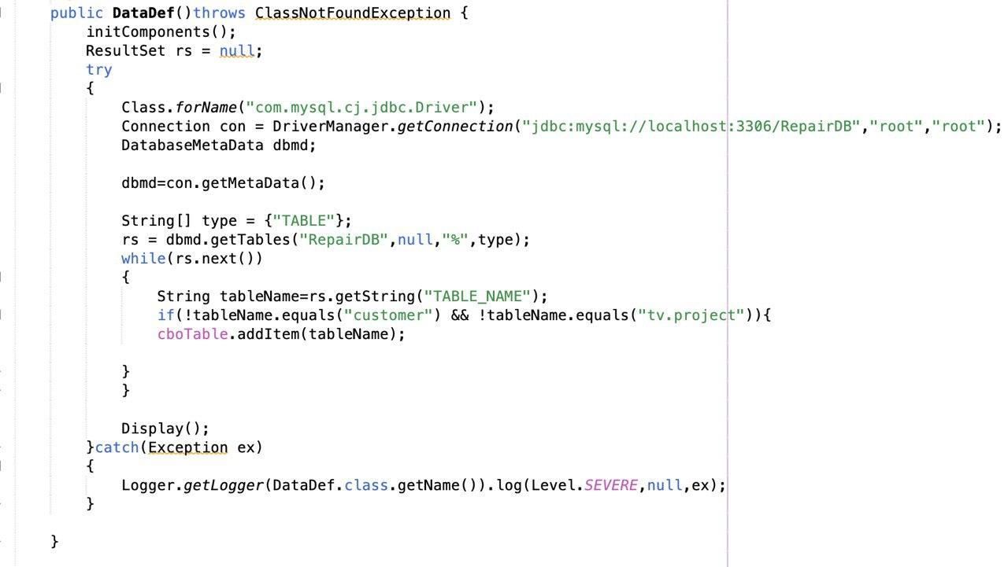

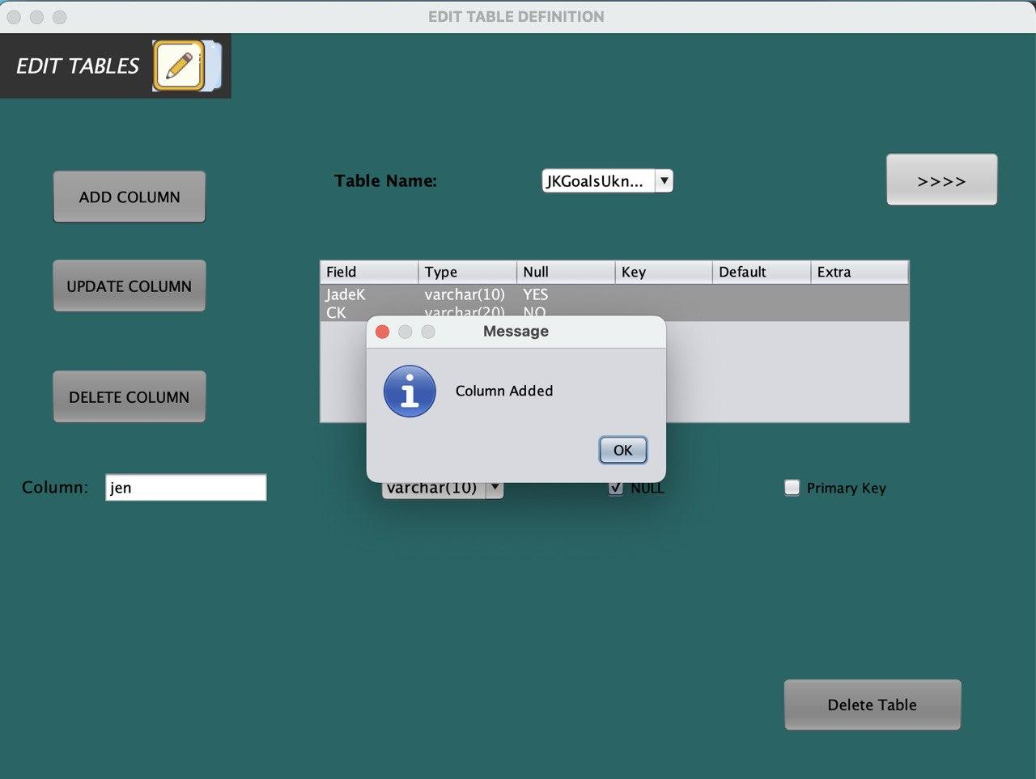

The client has the option to introduce a new column to the table by providing the necessary information and selecting its data type. Upon successful addition, a message indicating it will be displayed.

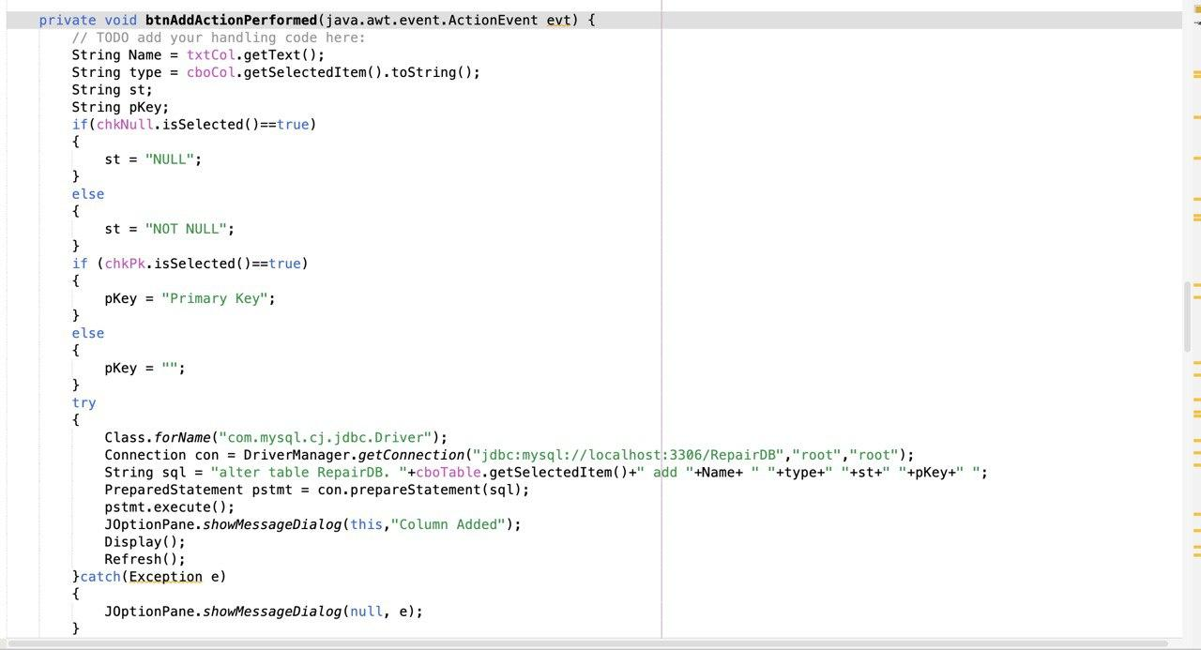



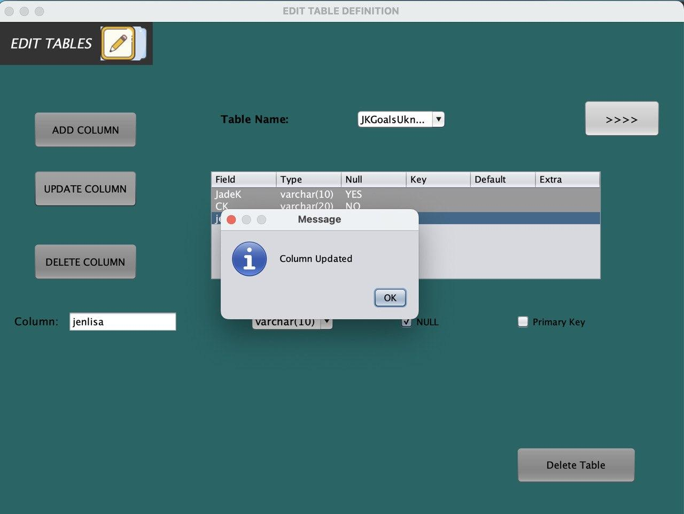

Selecting a row populates data in the corresponding controls. The user can input or select new data names and types before updating the row.

